



Essay / Assignment Title:

Programme title:
MSc Artificial Intelligence
Prepared by:
Amaan Mohammed Khalander
Year:
Term 1 – 2026
Date:
27 / May / 2026

Executive Summary

Table of Contents

Statement of compliance with academic ethics and the avoidance of plagiarism
I honestly declare that this dissertation is entirely my own work and none of its part has been copied from printed or electronic sources, translated from foreign sources and reproduced from essays of other researchers or students. Wherever I have been based on ideas or other people texts I clearly declare it through the good use of references following academic ethics.

(In the case that is proved that part of the essay does not constitute an original work, but a copy of an already published essay or from another source, the student will be expelled permanently from the postgraduate program).

Name and Surname:
AMAAN MOHAMMED KHALANDER
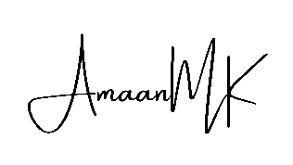
Date: 27 / May / 2026

Introduction

Main Body A: (title here)

Main Body B: (title here)

Main Body C: (title here)

Main Body D: (title here)

Main Body E: (title here)

Concluding Remarks

References

